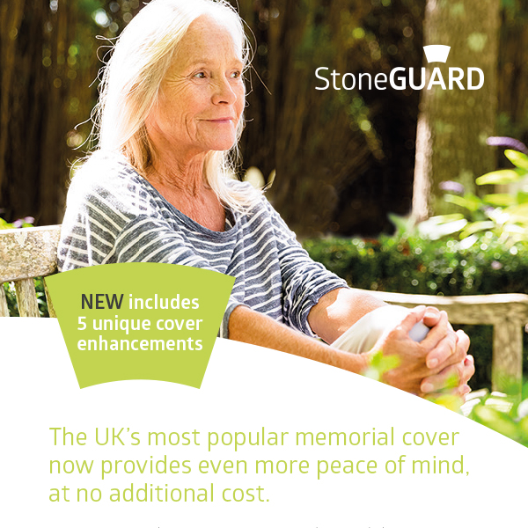

• **Tree sap damage cover**

**• Frost damage cover**

**• Non-weather staining damage cover**

**• Council topple testing cover**

**• A bereavement counselling phone line**